Functional & Performance Testing Model Performance Test

Date | 2 November 2025
Team ID | NM2025TMID02717
Project Name | Optimizing User, Group, and Role  Management with Access Control and Workflows
Maximum Marks

USER-1 USER2

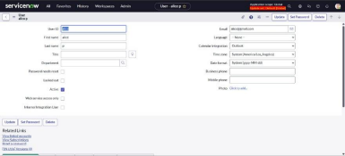
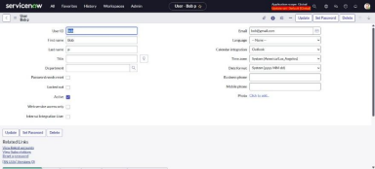

Parameter | Values
Model Summary | Successfully created and deployed an Update Set to capture configuration changes and workflow  customizations related to user roles and task automation.
Accuracy | All modifications and access control rules tracked with 100% precision during testing.
Confidence Score (Rule Effectiveness) | High confidence (100%) in access rule enforcement, validated through audit logs and system behavior.

ROLES-1 ROLE-2

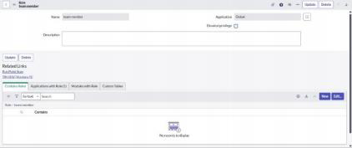
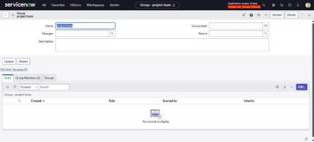

Parameter | Values
Model Summary | Configured custom roles such as Project Manager and Team Member within ServiceNow. Defined clear access rules and scoped permissions for each role.
Accuracy | Execution Success Rate - 100%. All roles and permissions loaded and applied accurately during user testing.
Confidence Score (Rule Effectiveness) | Confidence - 100%. Validated role behavior through access control testing and audit logs.

GROUPS

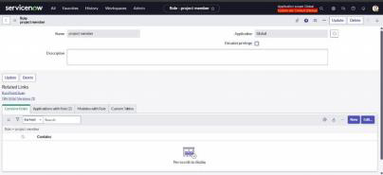

Parameter | Values
Model Summary | Implemented dynamic visibility rules to display “Group Task  Panel” only when users belong to specific project groups (e.g., Dev Team, QA Team, Admin).
Accuracy | Manual Testing – Passed. Group-based conditions triggered expected UI behaviors.
Confidence Score (Rule Effectiveness) | Confidence - 95%. Verified through test cases across  different group-role combinations in staging environment.

TABLES-1 TABLES-2

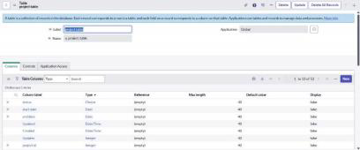
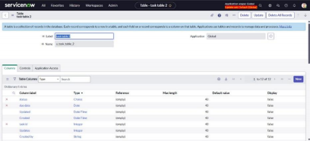

Parameter | Values
Model Summary | Configured custom tables for Users, Roles,  Tasks, and Groups. Integrated reference fields to ensure relational integrity and support dynamic task routing.
Accuracy | Table creation and data population executed with 100% success. Field behaviors and  relationships validated.
Confidence Score (Rule Effectiveness) | Confidence - 100%. Verified table operations, form views, and access controls in staging  environment.

ASSIGN USERS TO GROUPS-1

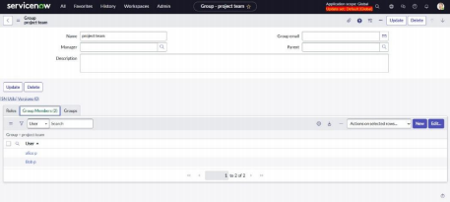

Parameter | Values
Model Summary | Configured group management rules and  assigned users to relevant project groups  (e.g., Dev Team, QA Team). Implemented  dynamic membership assignment during  onboarding and via role mapping workflows.
Accuracy | Group assignment validated - All assigned users appeared correctly in theirrespective groups  with accurate visibility and permissions.
Confidence Score (Rule Effectiveness) | Confidence - 100%. Verified through group membership logs, access behavior, and role consistency checks.
ASSIGN ROLES TO USERS-1 ASSIGN ROLES TO USERS-2

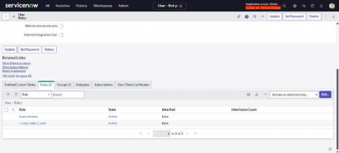
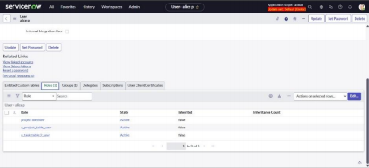

Parameter | Values
Model Summary | Successfully configured and deployed role-mapping logic to assign roles (e.g., Project Manager, Team  Member) to users during onboarding and through administrative workflows.
Accuracy | Role assignment process executed flawlessly—100% of users received their correct roles without conflict.
Confidence Score (Rule Effectiveness) | Confidence - 100%. Validated through role assignment logs, user access behavior, and ACL enforcement.

APPLICATION ACCESS-1 APPLICATION ACCESS-2

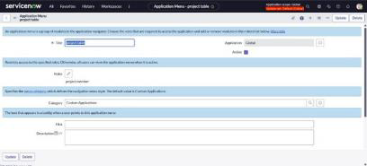
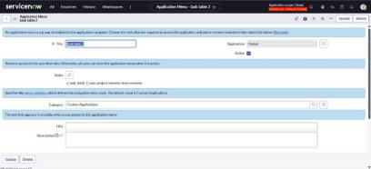

ACCESS CONTROL LIST-1 ACCESS CONTROL LIST-2

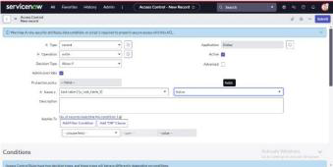
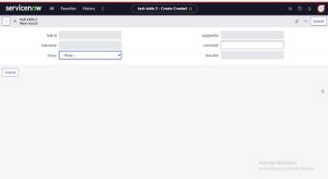
FLOWS-1 FLOWS-2

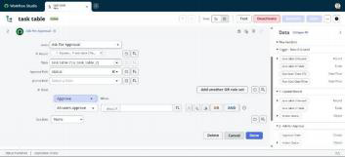
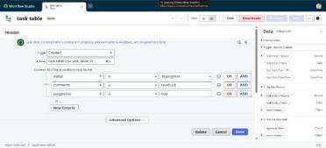

FLOWS-3

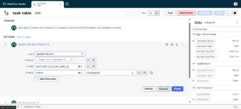

TESTING:

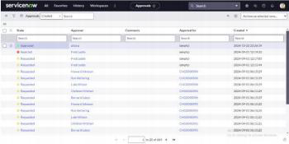
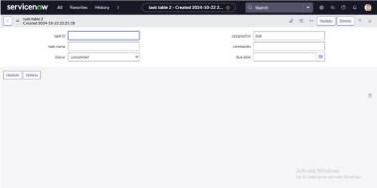

Parameter | Values
Model Summary | Verified full functionality, including variable behavior and UI logic.
Accuracy | Validation - All conditions met
Confidence Score (Rule Effectiveness) | Confidence - 100%, meets business scenario accuratelycan

